unit 2: Willington 100 years ago
SUBJECT  Social Studies | GRADE LEVEL(S)  2nd Grade | LOCATION  Willington, CT
SOCIAL STUDIES FRAMEWORK THEMES
Using evidence to learn about the past, connecting the past to the present.
TOPICS
Artifacts, Economy, Timelines, Comparing past vs. present

Dimension 1: potential compelling question

Lesson 1: Thinking like a Historian
Introduce Willington’s past economy built upon mills and factories with observing and exploring different artifacts and writing about them. Students will develop questions about the artifacts and how they relate to Willington 100 years ago. They will explore artifacts on their own in groups after the teacher models how to do so to the whole class, they will keep detailed notes about their observations and thoughts.

Standards
CT SOCIAL STUDIES FRAMEWORKS  HIST 2.6: Identify different kinds of historical sources.  HIST 2.7: Explain how historical sources can be used to study the past.  HIST 2.8: Identify the maker, date, and place of origin for a historical source from information within the source itself.  HIST 2.9: Generate questions about a particular historical source as it relates to a particular historical event or development.  ECO 2.3: Describe the goods and services that people in the local community produce and those that are produced in other communities. | CCSS  CCSS.ELA-LITERACY.SL.2.1: Participate in collaborative conversations with diverse partners about grade 2 topics and texts with peers and adults in small and larger groups.  CCSS.ELA-LITERACY.SL.2.3: Ask and answer questions about what a speaker says in order to clarify comprehension, gather additional information, or deepen understanding of a topic or issue.

inquiry based learning activity: willington button shops
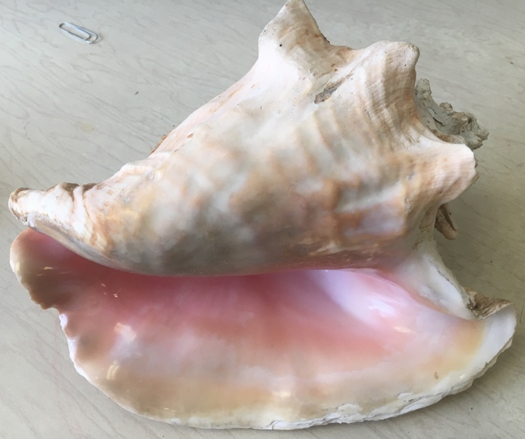
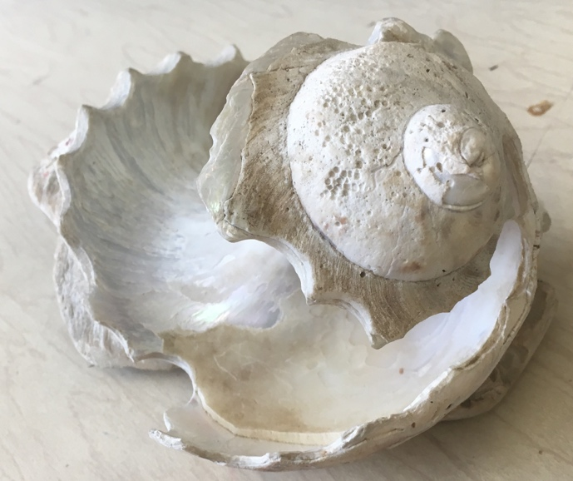

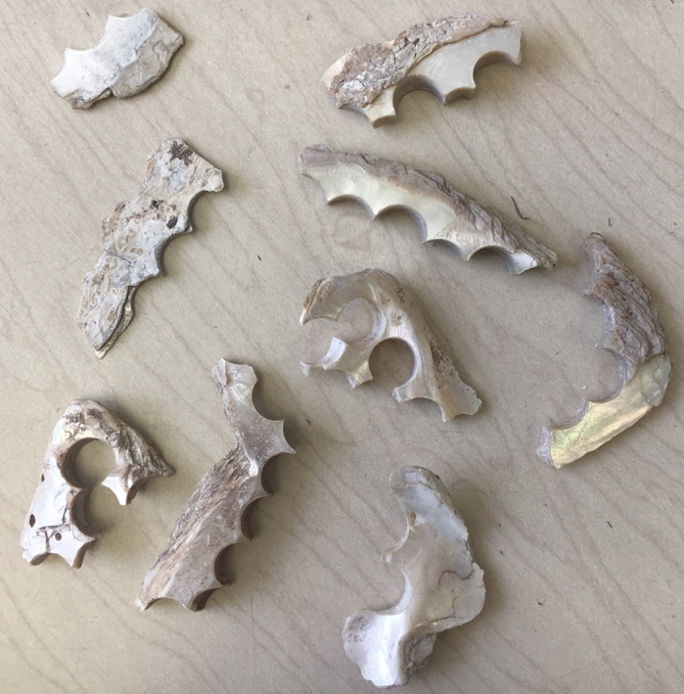
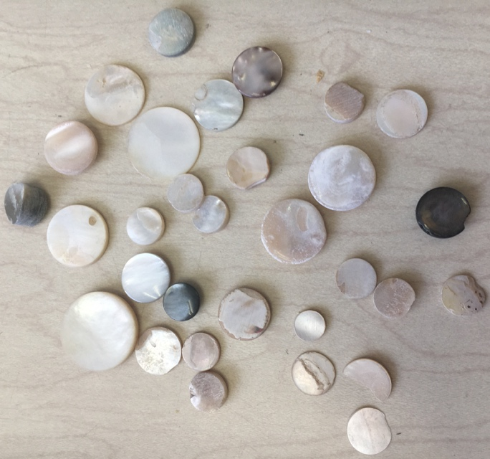

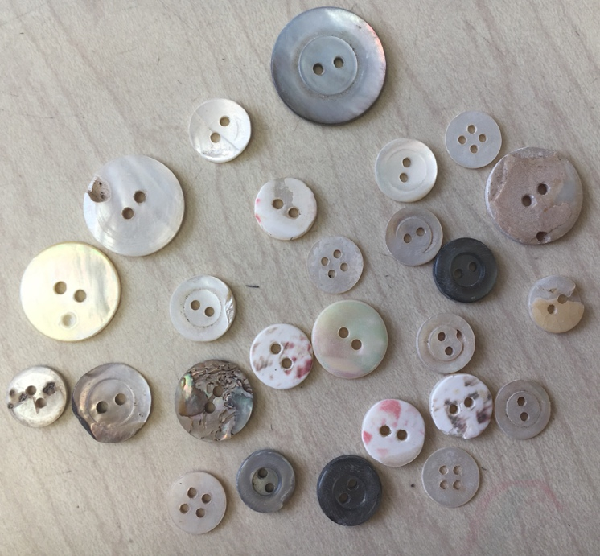
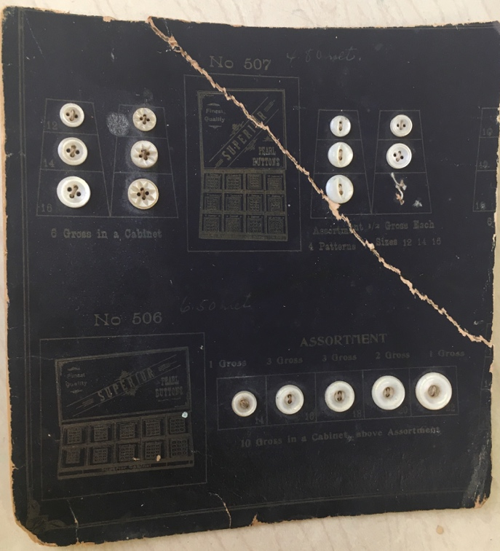

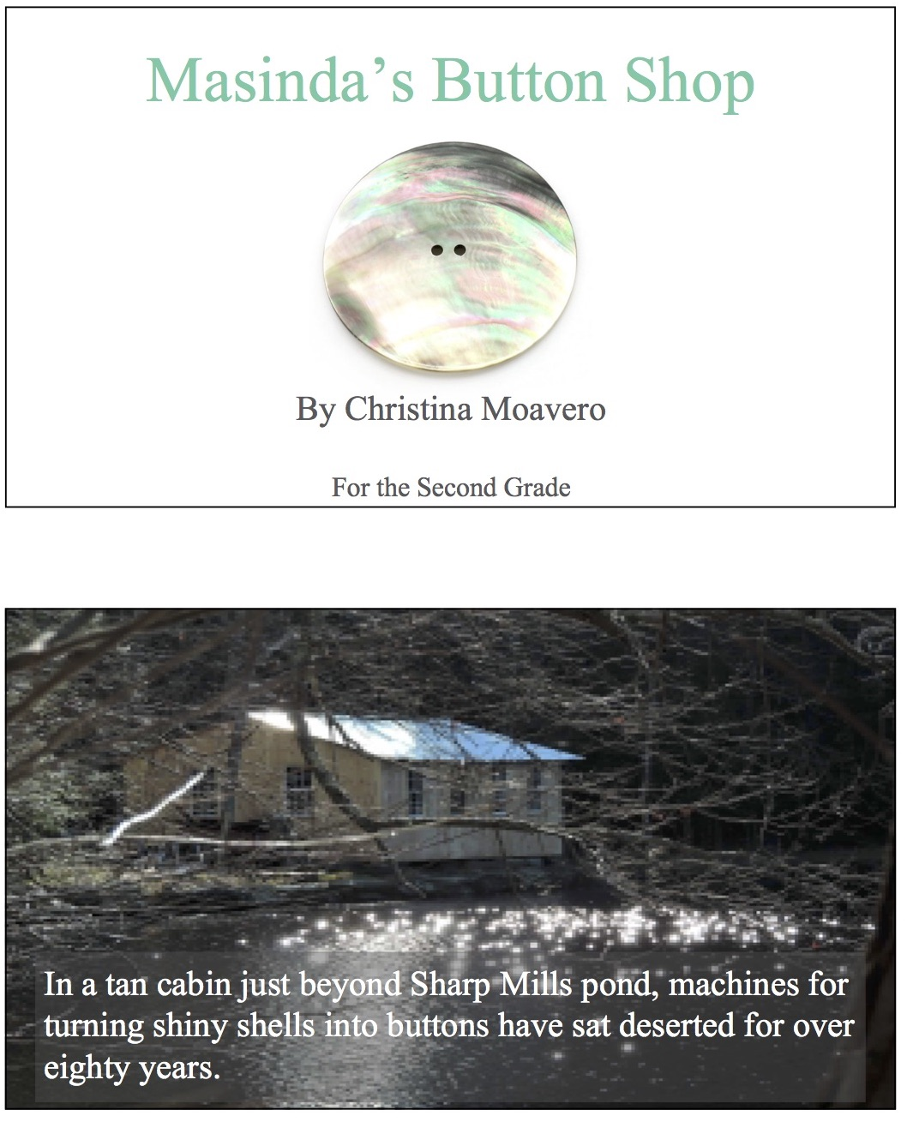

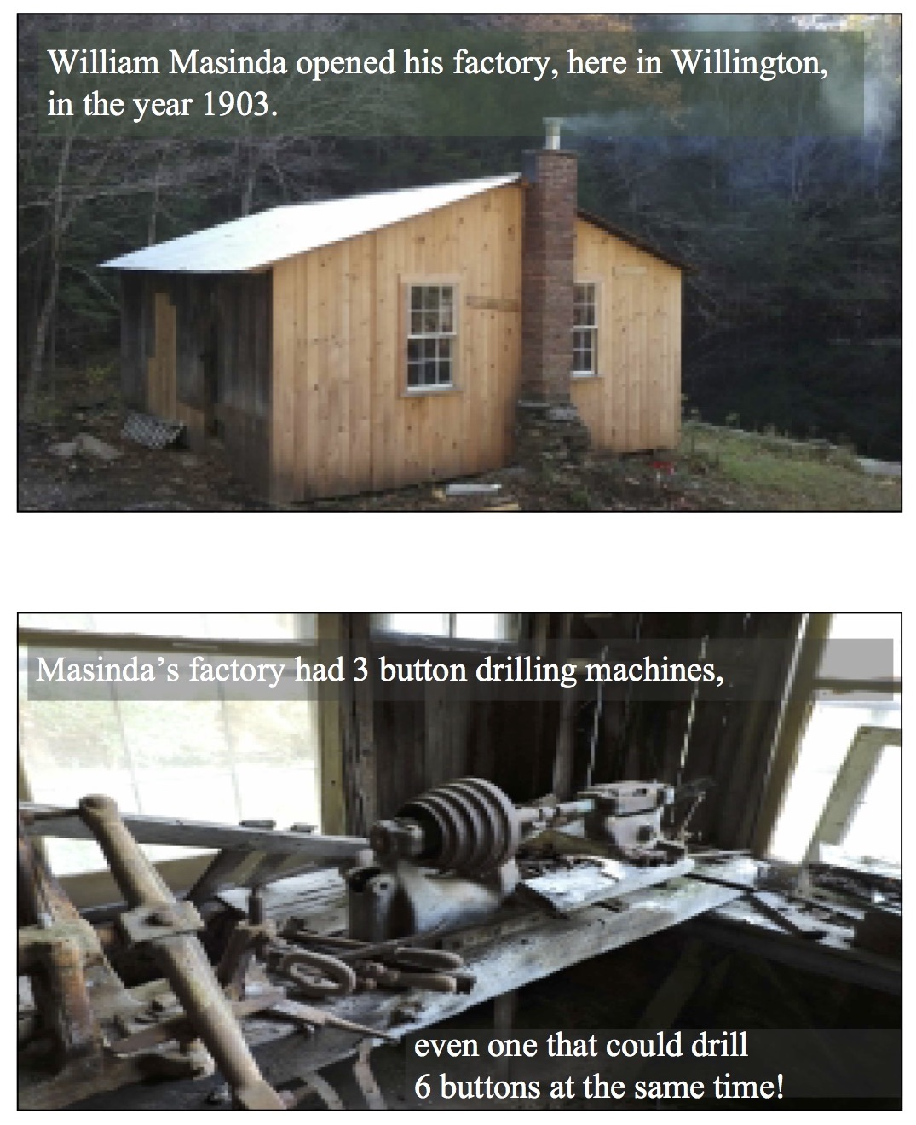
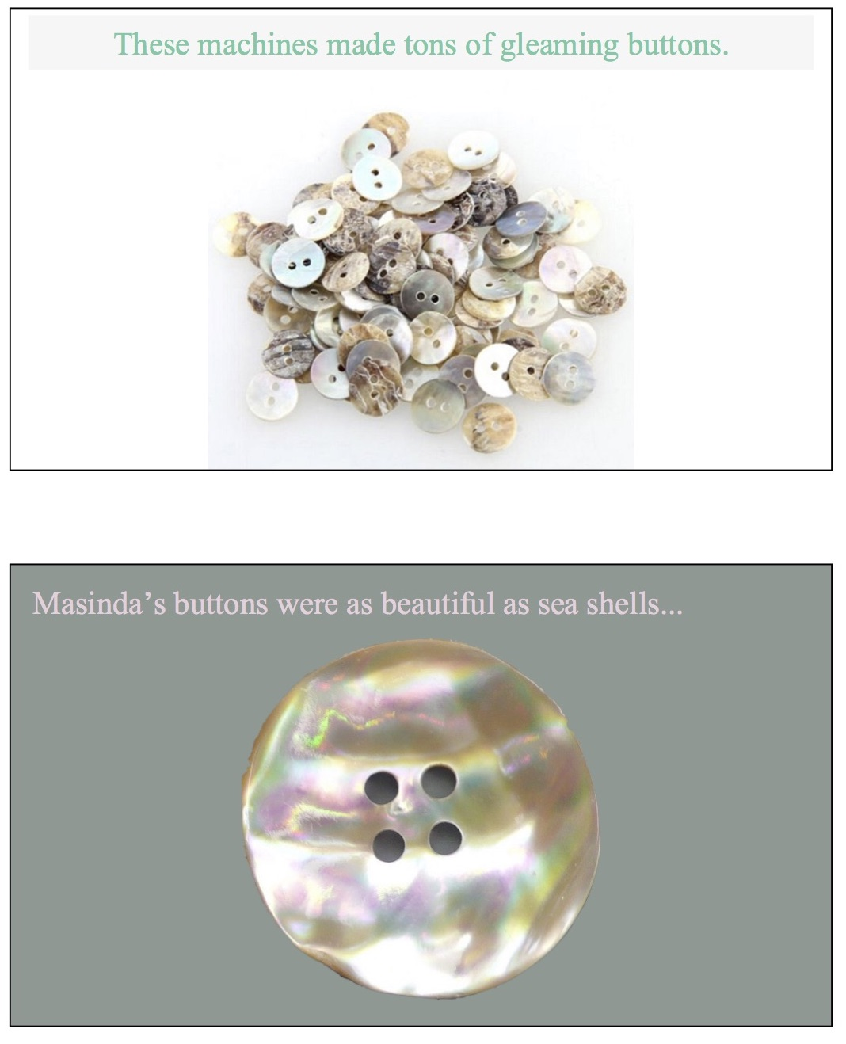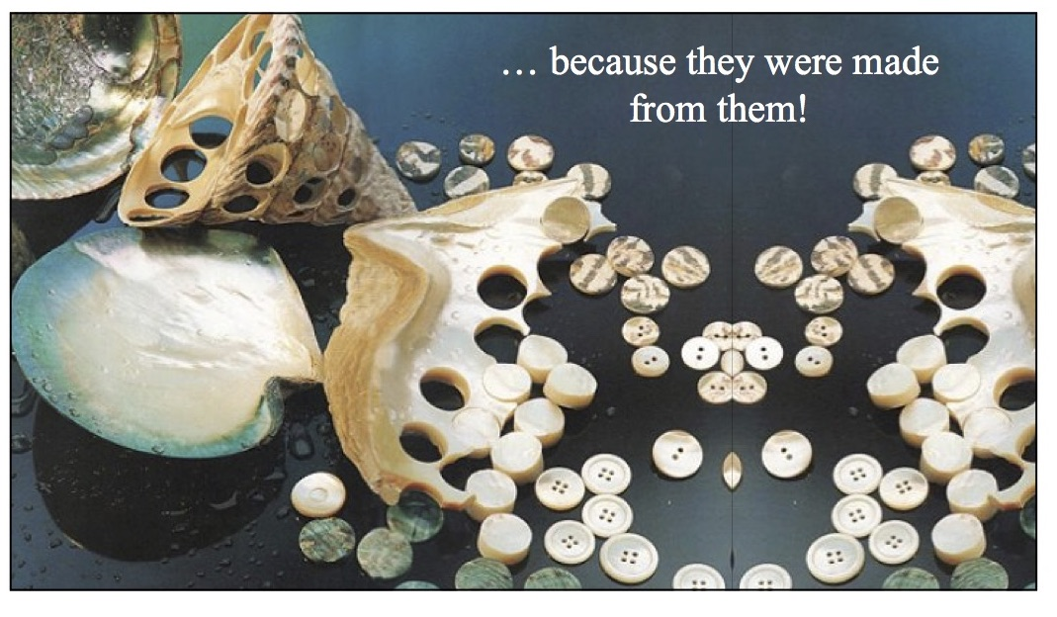

inquiry based learning activity: willington glass factories
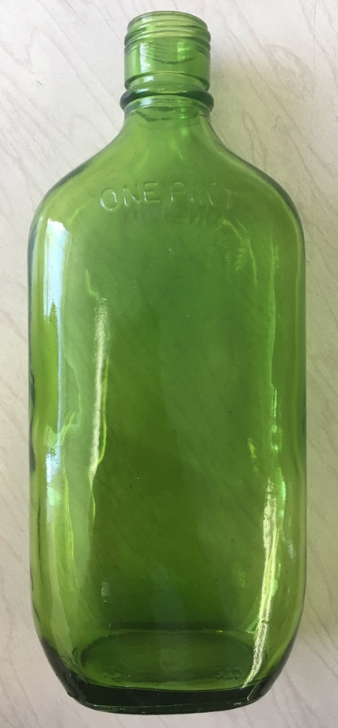

inquiry based learning activity: willington cotton mills
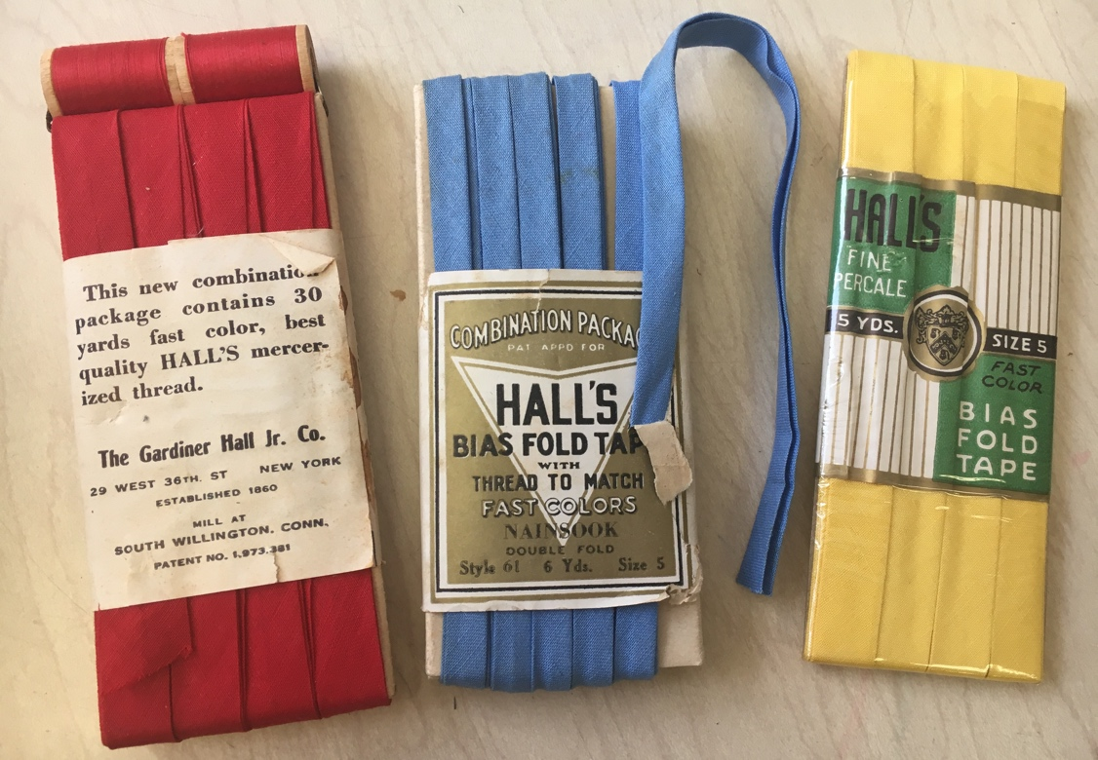

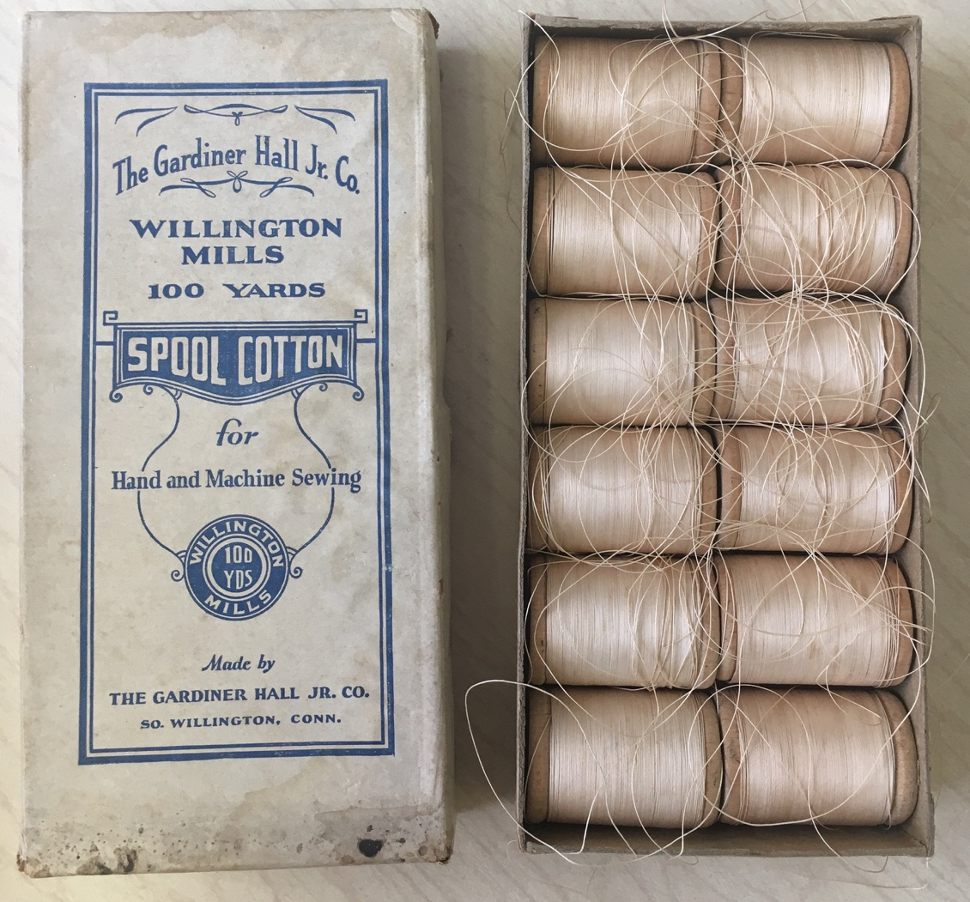

dimension 2: disciplineary concepts & tools

Lesson 2: Visual Thinking Strategies & The life of willington kids 100 years ago
Teach the students about the life of a child in Willington 100 years ago with a VTS activity of real photographs of children and places in Willington’s past. This will teach students the concept that life 100 years ago was different than it is now. It will also teach them the disciplinary tool of observing primary sources (old photographs) by using visual thinking strategies to learn about the past.

Standards
SOCIAL STUDIES FRAMEWORKS  INQ K–2.7: Evaluate a source by distinguishing between facts and opinion.  INQ K–2.6: Gather relevant information from one or two sources while using the origin and structure to guide the selection | CCSS  CCSS.ELA-LITERACY.SL.2.1: Participate in collaborative conversations with diverse partners about grade 2 topics and texts with peers and adults in small and larger groups.  CCSS.ELA-LITERACY.SL.2.1.A: Follow agreed-upon rules for discussions (e.g., gaining the floor in respectful ways, listening to others with care, speaking one at a time about the topics and texts under discussion).

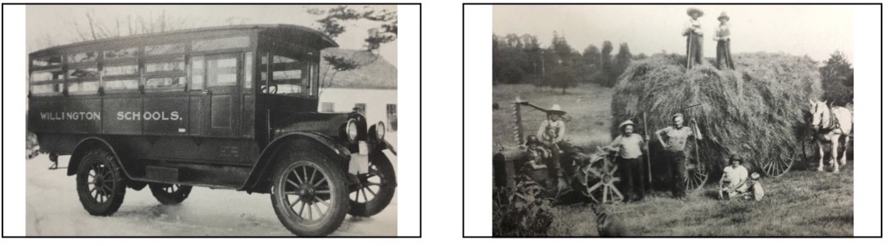

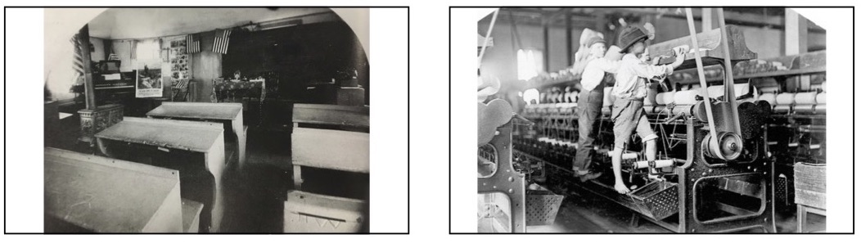

Dimension 3: evaulating sources and using evidence

lesson 3: timelines of the past & present
Teach the students how to create a timeline of the average day of a Willington kid from 100 years ago, use the video as a primary source to evaluate what life was like for an average kid 100 years ago. When brainstorming what they could do during the day when you model how to make a timeline, use evidence from the video or even the pictures from Lesson 2 to backup your ideas. Students will then create their own timelines about a day in their life.

Standards
SOCIAL STUDIES FRAMEWORKS  HIST 2.1: Create a chronological sequence of multiple events.  HIST 2.2: Compare life in the past to life today. | CCSS  CCSS.MATH.CONTENT.2.MD.B.6: Represent whole numbers as lengths from 0 on a number line diagram with equally spaced points corresponding to the numbers 0, 1, 2, ..., and represent whole-number sums and differences within 100 on a number line diagram.
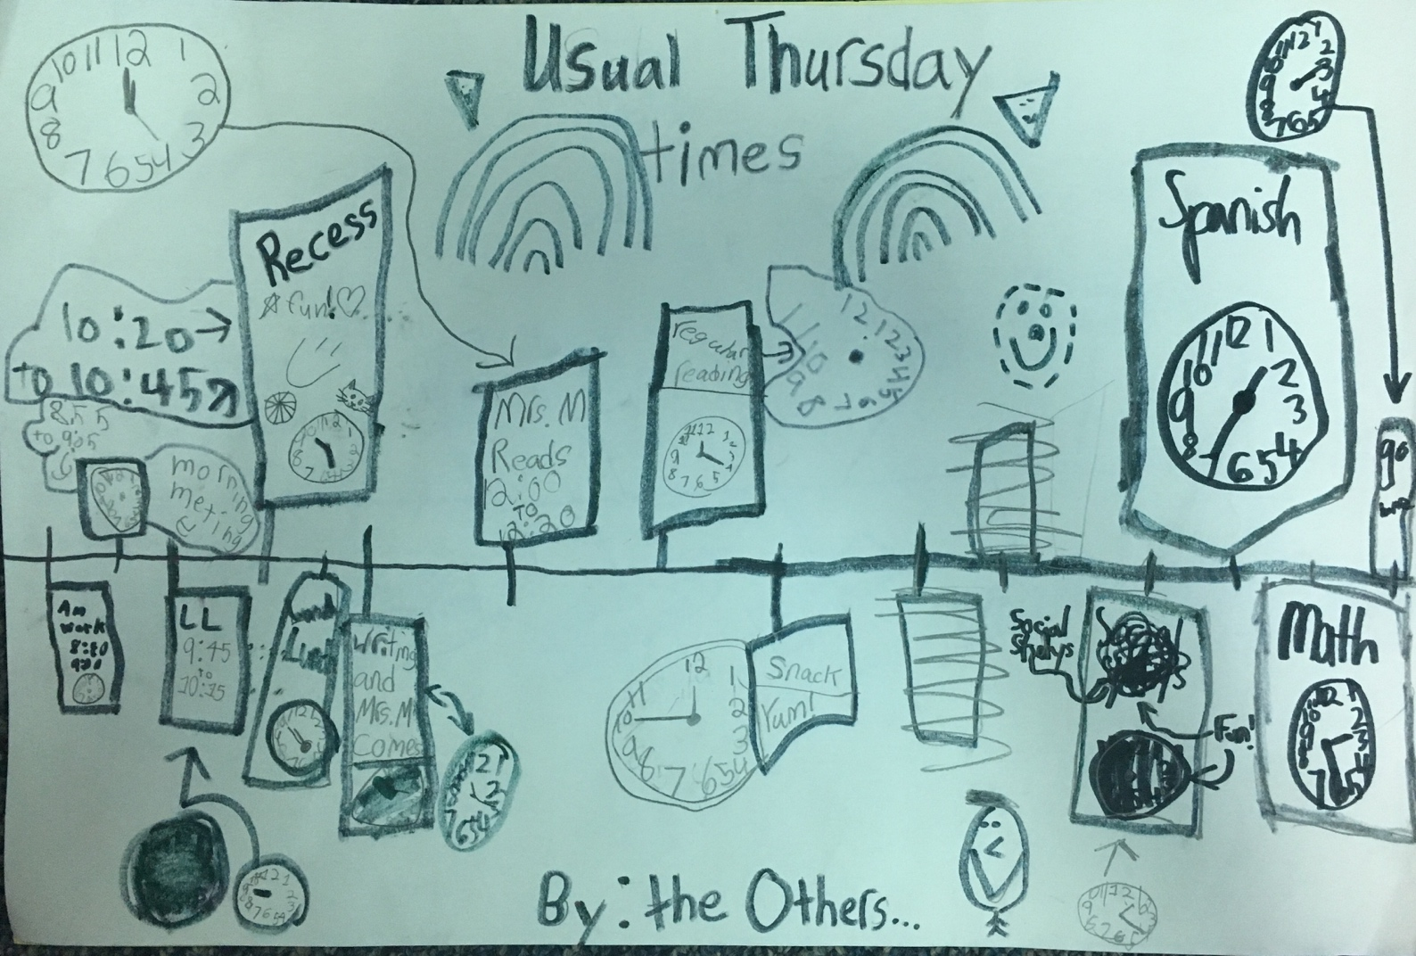

dimension 4: communicating conclusions

lesson 4: comparing the past and present
Students compare and contrast their timelines with the class’ timeline of a kid from 100 years ago. They will write what the differences and similarities are and why they think life is different now. They will be posed with the question, is life better now than it was 100 years ago? How do you think you can make life in Willington better for the future?

Standards
CT SOCIAL STUDIES FRAMEWORKS  HIST 2.2: Compare life in the past to life today.  HIST 2.4: Explain perspectives of people in the past to those of people in the present.  CIV 2.4: Compare their own point of view with others’ perspectives.  INQ K–2.10: Construct an argument with reasons.  INQ K–2.12: Present a summary of an argument using print, oral, and digital technologies. | CCSS  CCSS.ELA-LITERACY.SL.2.1: Participate in collaborative conversations with diverse partners about grade 2 topics and texts with peers and adults in small and larger groups.  CCSS.ELA-LITERACY.W.2.1: Write opinion pieces in which they introduce the topic or book they are writing about, state an opinion, supply reasons that support the opinion, use linking words (e.g., because, and, also) to connect opinion and reasons, and provide a concluding statement or section.

