unit 1: Me museum
SUBJECT  Social Studies | GRADE LEVEL(S)  2nd Grade | LOCATION  Willington, CT
SOCIAL STUDIES FRAMEWORK THEMES
Using evidence to learn about the past, connecting the past to the present.
TOPICS
Artifacts, Museums, Life in Willington, Informational Writing, Gallery Walk, Comparing Perspectives

Dimension 1: potential compelling question

Lesson 1: Introducing the concept of artifacts
- Students will be introduced to the concept of an artifact and explore a model “Me Museum” documenting life at the University of Connecticut. Homework is to collect artifacts documenting life in present day Willington.

Standards
CT SOCIAL STUDIES FRAMEWORKS  INQ K-2.3: Identify facts and concepts associated with a supporting question.  HIST 2.6: Identify different kinds of historical sources.  HIST 2.7: Explain how historical sources can be used to study the past.  CIV 2.2: Follow agreed upon rules for discussion while responding attentively to others when addressing ideas and making decisions as a group. | CCSS  CCSS.ELA-LITERACY.SL.2.1: Participate in collaborative conversations with diverse partners about grade 2 topics and texts with peers and adults in small and larger groups.  CCSS.ELA-LITERACY.SL.2.3: Ask and answer questions about what a speaker says in order to clarify comprehension, gather additional information, or deepen understanding of a topic or issue.

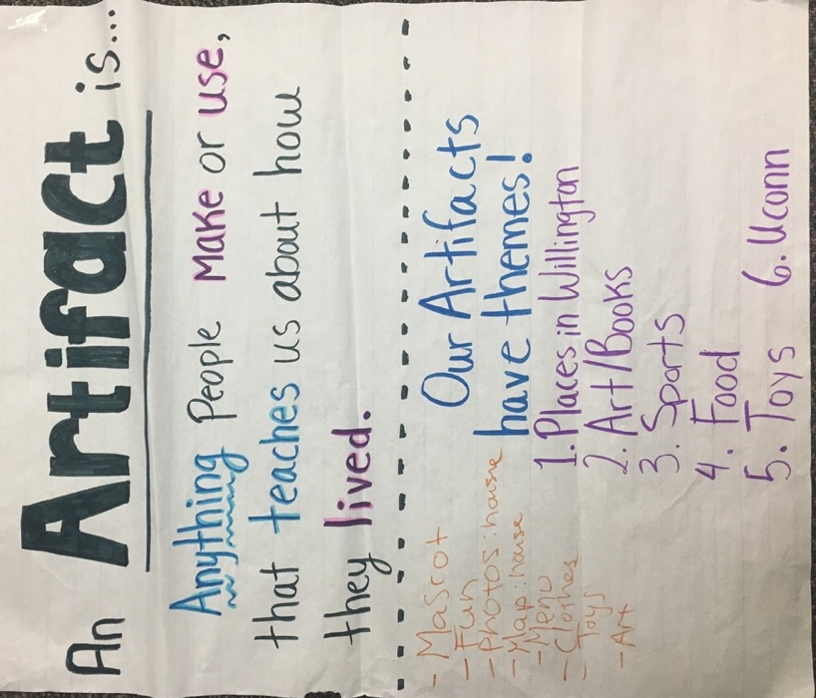
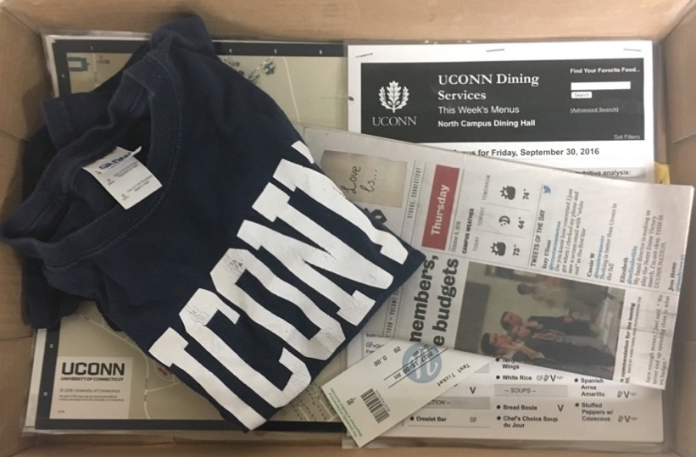

Anchor chart: used to teach the vocabulary word “Artifact”. UConn Artifacts: teacher model for me museum.
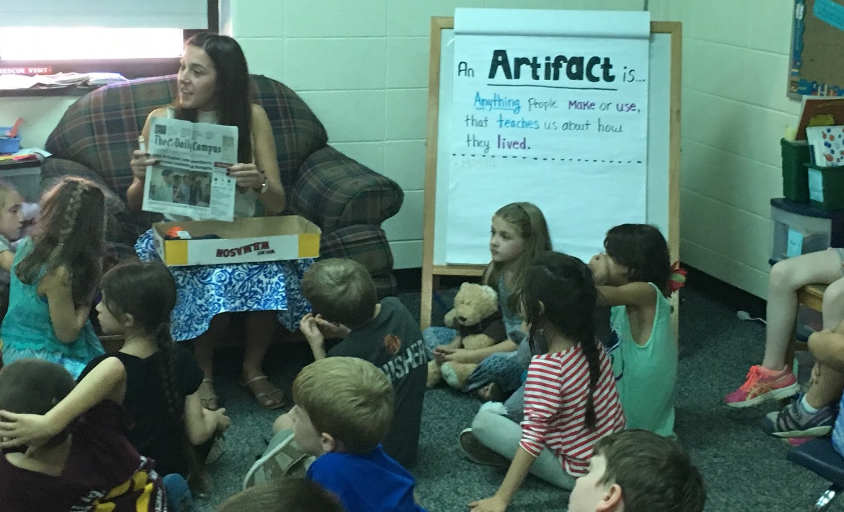

Discussing the artifacts in the model UConn me museum: what do they teach us about life for people at UConn?
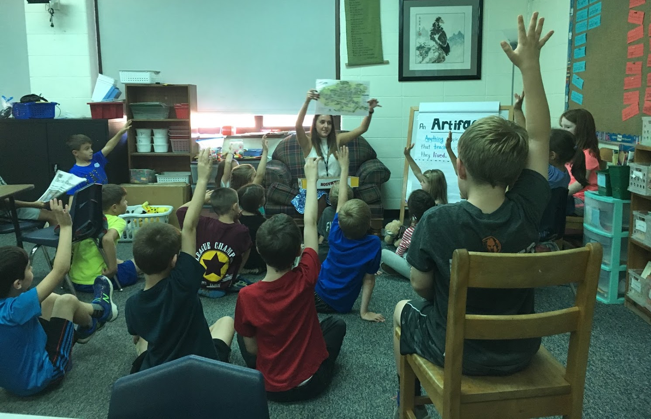

dimension 2: disciplineary concepts & tools

Lesson 2: introducing the concept of a museum & creating our me museum
- Students will be introduced to the concept of a museum.
- Students will explore an interactive map of a real museum to discover how museums are organized.
- Students will come up with themes to organize their class Me Museum.
- Students will create a class museum housed and categorized in multiple box tops with artifacts brought from home documenting their life in present day Willington.

Standards
SOCIAL STUDIES FRAMEWORKS  HIST 2.6: Identify different kinds of historical sources.  HIST 2.7: Explain how historical sources can be used to study the past.  CIV 2.2: Follow agreed upon rules for discussion while responding attentively to others when addressing ideas and making decisions as a group.  INQ K-2.17: Use listening, consensus-building, and voting procedures to decide on and take action in their classroom. | CCSS  CCSS.ELA-LITERACY.SL.2.1: Participate in collaborative conversations with diverse partners about grade 2 topics and texts with peers and adults in small and larger groups.  CCSS.ELA-LITERACY.SL.2.3: Ask and answer questions about what a speaker says in order to clarify comprehension, gather additional information, or deepen understanding of a topic or issue.

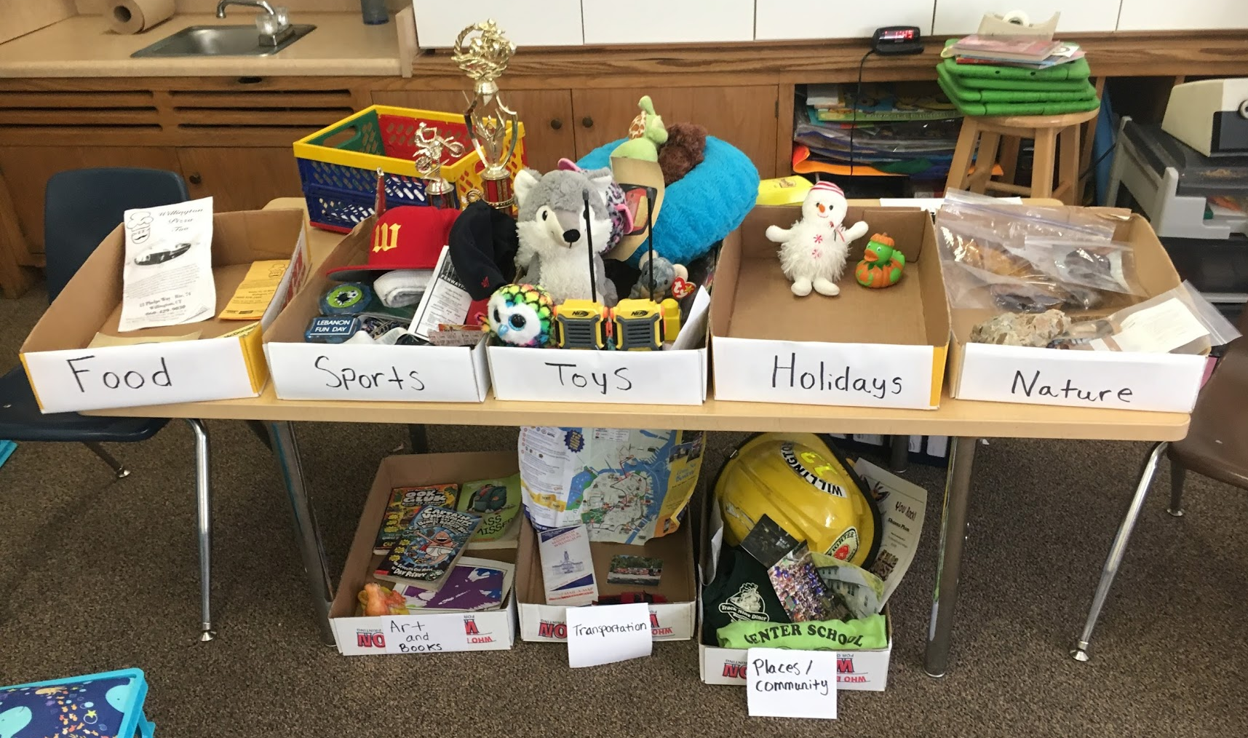

Completed Me Museum: with labeled categories and student artifacts.

Dimension 3: evaulating sources and using evidence

lesson 3: writing about an artifact
- Students choose one of the artifacts they brought in for their Me Museum and write about what you can learn about them from the artifact. 3 differentiated options.

Standards
SOCIAL STUDIES FRAMEWORKS  HIST 2.6: Identify different kinds of historical sources.  HIST 2.7: Explain how historical sources can be used to study the past.  CIV 2.2: Follow agreed upon rules for discussion while responding attentively to others when addressing ideas and making decisions as a group.  CIV 2.5: Explain how people can work together to make decisions in the classroom.  INQ K-2.6: Gather relevant information from one or two sources while using the origin and structure to guide the selection.  INQ K-2.10: Construct an argument with reasons.  INQ K-2.12: Present a summary of an argument using print, oral, and digital technologies. | CCSS  CCSS.ELA-LITERACY.W.2.2: Write informative/explanatory texts in which they introduce a topic, use facts and definitions to develop points, and provide a concluding statement or section.  CCSS.ELA-LITERACY.W.2.6: With guidance and support from adults, use a variety of digital tools to produce and publish writing, including in collaboration with peers.  CCSS.ELA-LITERACY.W.2.8: Recall information from experiences or gather information from provided sources to answer a question.  CCSS.ELA-LITERACY.SL.2.5: Create audio recordings of stories or poems; add drawings or other visual displays to stories or recounts of experiences when appropriate to clarify ideas, thoughts, and feelings.
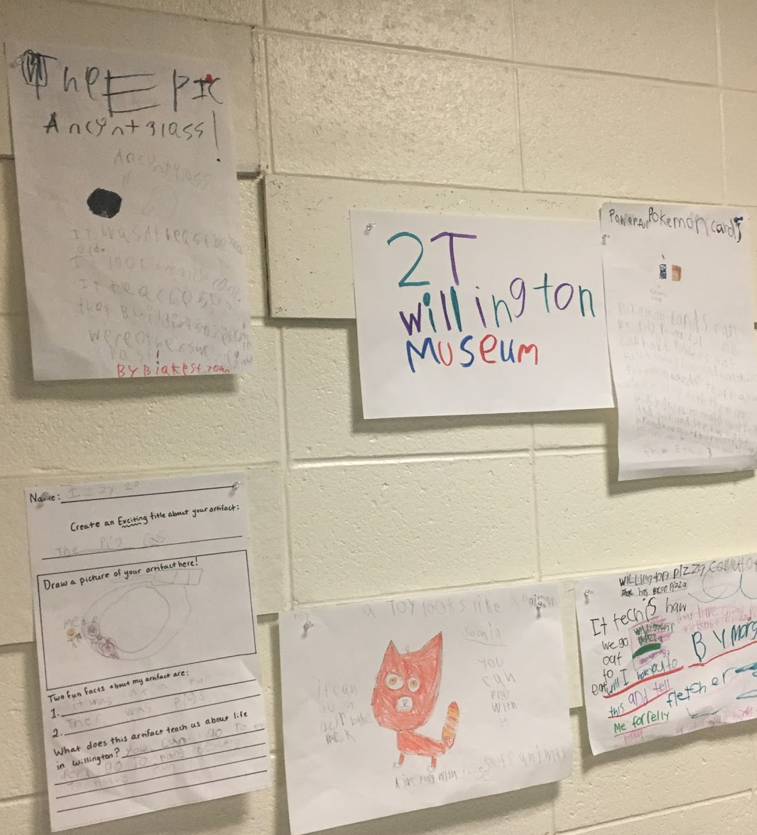
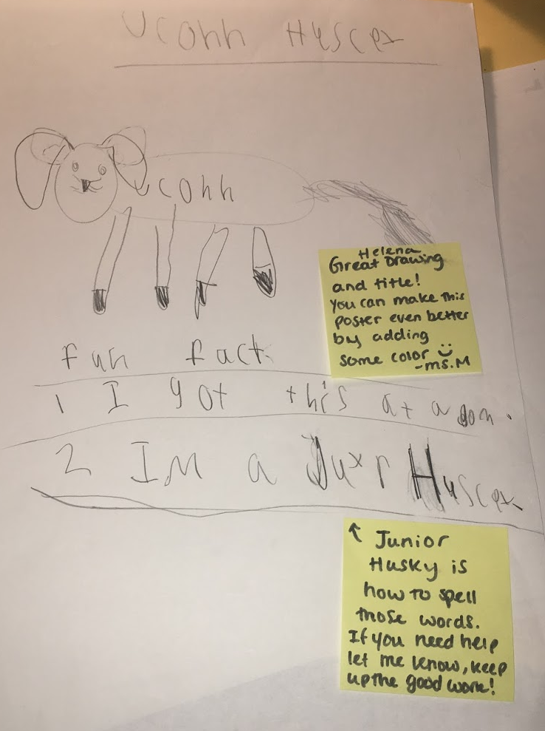

Posters students created about artifacts in the me
Museum to advertise it to the school community.

Student Informational Writing about the artifacts in the me museum. They each wrote about an artifact on their Chromebook, printed it and added illustrations. Then they combined them all to create a class book. 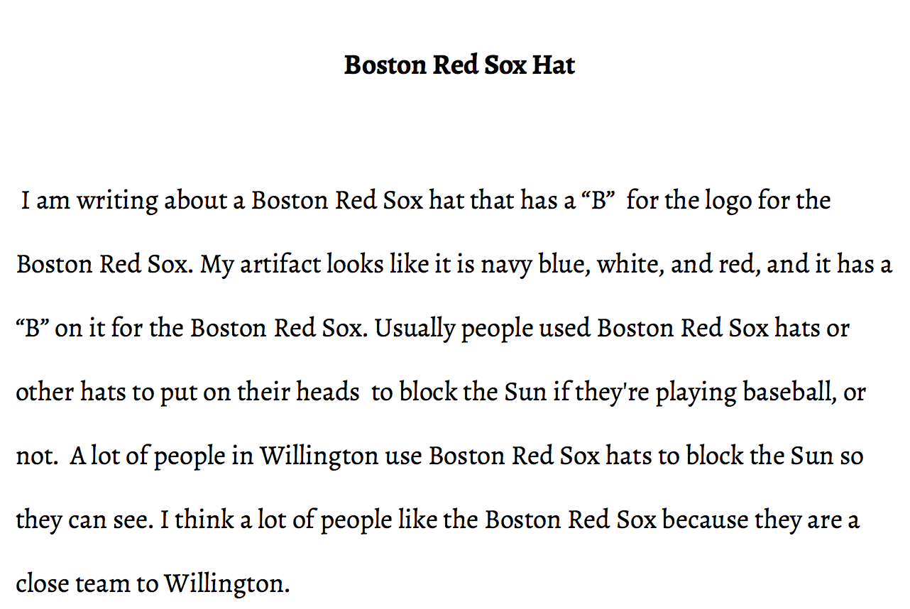
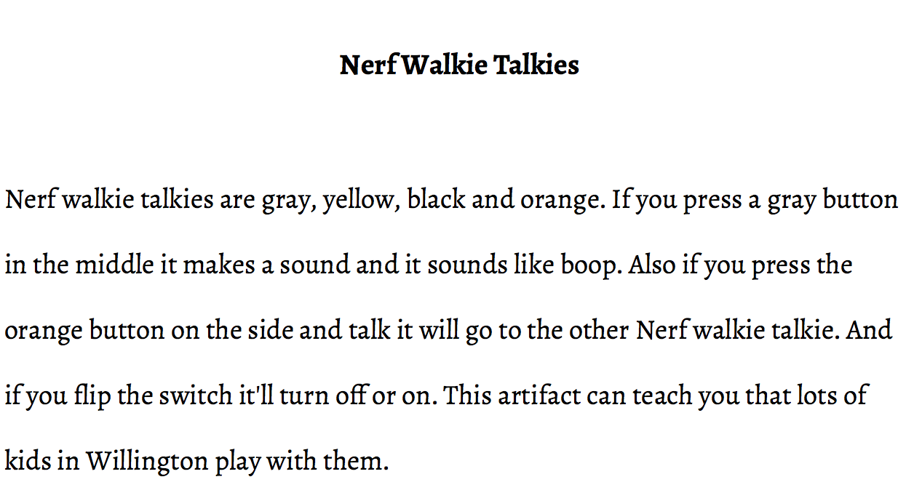

dimension 4: communicating conclusions

lesson 4: gallery walk
- The two second grade classes visit each other’s Me Museums
- What is similar/different about the organization/the items in their collection? Venn Diagram on SMART Board.
- If they’re in the same community, why do you think each class has different artifacts? (Comparing Perspectives)

Standards
CT SOCIAL STUDIES FRAMEWORKS  HIST 2.5: Compare different accounts of the same historical event.  HIST 2.6: Identify different kinds of historical sources.  HIST 2.7: Explain how historical sources can be used to study the past.  CIV 2.2: Follow agreed upon rules for discussion while responding attentively to others when addressing ideas and making decisions as a group.  INQ K–2.11: Construct explanations using correct sequence and relevant information.  INQ K-2.17: Use listening, consensus-building, and voting procedures to decide on and take action in their classroom. | CCSS  CCSS.ELA-LITERACY.SL.2.1: Participate in collaborative conversations with diverse partners about grade 2 topics and texts with peers and adults in small and larger groups.  CCSS.ELA-LITERACY.SL.2.3: Ask and answer questions about what a speaker says in order to clarify comprehension, gather additional information, or deepen understanding of a topic or issue.
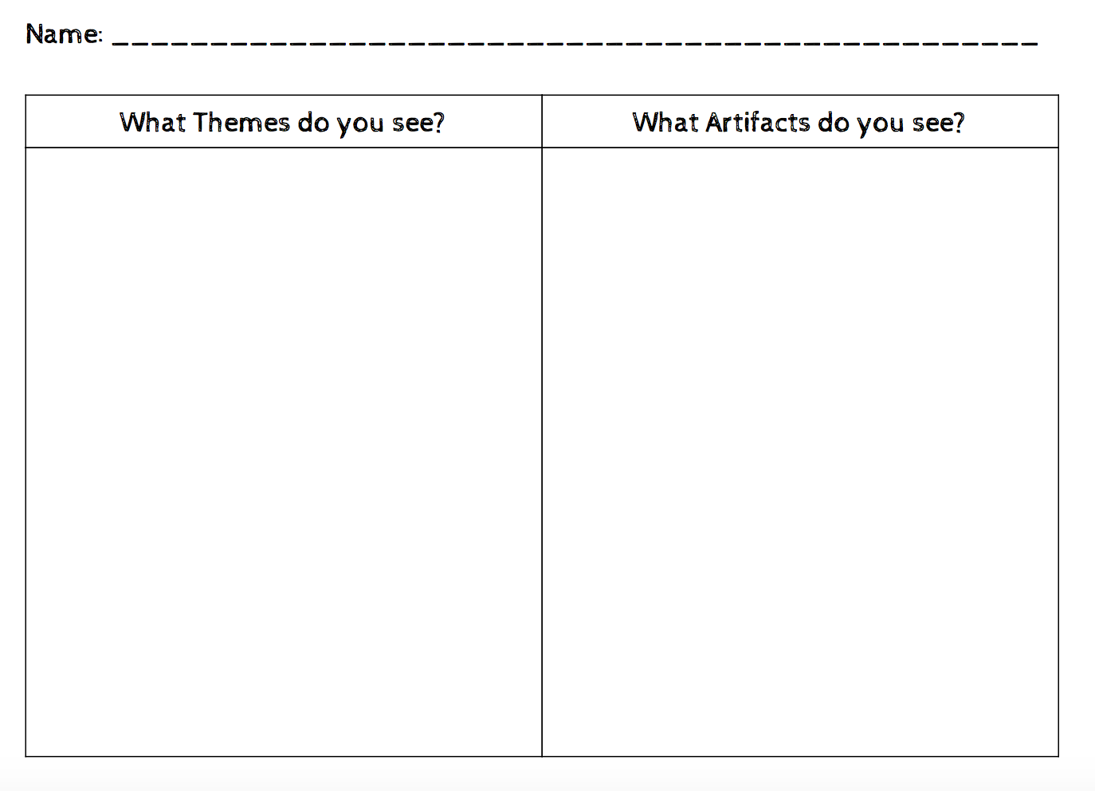
Worksheet students used during the gallery walk to organize their ideas. They used it during the venn diagram to remind them what themes and artifacts the other me museum had.

